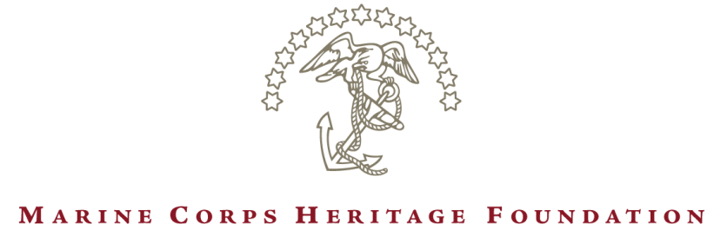

FOR IMMEDIATE RELEASE
CONTACT: Matthew Morrissey
202-414-0781 mmorrissey@susandavis.com

Prestigious Marine Corps Heritage Foundation Annual Award Winners Announced

Triangle, Va. – The Marine Corps Heritage Foundation is pleased to announce recipients of the Foundation's 2023 Annual Awards, who will be honored at the Annual Awards Dinner on April 29 at the National Museum of the Marine Corps.

Among the distinguished award winners are the Honorable Richard V. Spencer, Former Secretary of the Navy, who will receive the Heritage Award for exceptional support of the Foundation's mission; Sergeant Thomas Brennan, USMC (Ret), a Marine Corps veteran and founder of the nonprofit newsroom The War Horse, who will be awarded the Lieutenant General John A. Lejeune Recognition for Exemplary Leadership; Pulitzer Prize-winning author H.G. "Buzz" Bissinger and Pulitzer Prize-winning Washington Post journalist Dan Lamothe. The award winners are acknowledged for their exceptional portrayal of Marine Corps history, traditions, and culture in various fields including photography, documentaries, journalism, poetry, and nonfiction and fiction writing.

"Through their exceptional talent, these outstanding writers, artists, and photographers explore the rich history, traditions, and culture of the Marine Corps,” said Major General James W. Lukeman, USMC (Ret), the Foundation's President and CEO. "We are privileged to highlight their remarkable work with our Foundation's annual awards and hope that their example inspires others to tell the story of our Marine Corps.”

Accomplished Marine and civilian experts judge the Annual Awards. Past winners include celebrated novelists, best-selling authors, national columnists, network producers, and active-duty Marines with remarkable talent. The Foundation acknowledges their contributions in recognizing the challenge and importance of accurately conveying the Marine Corps' story. Many of the previous awardees have put themselves in harm's way to witness firsthand the dangerous work of Marines operating in the world's most remote locations.

Each winner of the Annual Awards will receive a gold medallion, a commemorative brick along the Semper Fidelis Memorial Park pathway adjacent to the National Museum of the Marine Corps, and, in some instances, a cash prize.

2023 Annual Awards recipients are listed below. For interviews with award recipients, please contact Matt Morrissey at mmorrissey@susandavis.com or 202-414-0781.

- The Colonel Joseph Alexander Award (biography or autobiography)
Lieutenant Colonel John B. Lang, USMC (Ret) for “A Final Valiant Act: The Story of Doug Dickey, Medal of Honor”
- The Master Sergeant Tom Bartlett Award (feature writing by an enlisted Marine)
Mac Caltrider for “Don’t Give Up the Ship: Why The Navy's Mantra Really Belongs To The Marines”
- The Lieutenant William Broyles Award (dramatic work)
Francisco Martínezcuello for “Salsa Night”
- The Sergeant Major Dan Daly Award (photography - album)
Warrant Officer Kowshon Ye for “Sangin”
- The Robert A. Gannon Award (poetry)
Mason Rodrigue for “Rock Eater”
- The General Roy S. Geiger Award (published aviation article)
Nancy Lichtman for "A Career Filled With Adventure For Apollo 13's Fred Haise"
- The Sergeant William Genaust Award (short subject documentary)
Corporal Moises Rodriguez, USMC for “The Fight Against Landmines”

- The General Wallace M. Greene, Jr. Award (general non fiction)
Buzz Bissinger for “The Mosquito Bowl”

- The Major Norman Hatch Award (feature documentary)
David C. Kniess, Jr. for “The Gift”
- The Colonel Robert D. Heinl, Jr. Award (feature writing)
Jonathan A. Bernstein for "Atomic Leathernecks: Nuclear Rocket Artillery in the Cold War"
- The Sergeant Major Bradley Kasal Award (single photo)
Lance Corporal Sydni Jessee, USMC for “U.S. Marines Participate in Martial Arts Instructor course”

- The Colonel John Magruder Award (exhibits & historical displays)
Lieutenant Colonel Nicolas Pomaro, USMC for “4th Assault Amphibian Battalions Heritage Room”

- The Major Megan McClung Award (reporting by an individual covering U.S. Marines abroad)
Dan Lamothe for “For U.S. troops who survived Kabul airport disaster, guilt and grief endure”
- The Eugene Sledge Award (memoir)
Kacy Tellessen for “Freaks of a Feather”
- The General Oliver P. Smith Award (local news reporting)
Russell Worth Parker for “Render Safe”
- The Colonel John W. Thomason, Jr. Award (combat art)
Marcus Poole for “A series of historical aviation oil paintings”
- The James Webb Award (fiction)
Mark Treanor for “A Quiet Cadence”

About the Marine Corps Heritage Foundation:
Dedicated to the preservation and promulgation of Marine Corps history, the Marine Corps Heritage Foundation was established in 1979 as a non-profit 501(c)(3) organization. The Foundation supports the historical programs of the Marine Corps in ways not possible through government funds. The Foundation provides grants and scholarships for research and the renovation, restoration and commissioning of historical Marine Corps artifacts and landmarks. The Foundation secured the necessary funding for the construction of the National Museum of the Marine Corps and Heritage Center, located in Triangle, Virginia, and continues to expand programs at the National Museum of the Marine Corps and beyond its walls. For more information, visit MarineHeritage.org.

###

